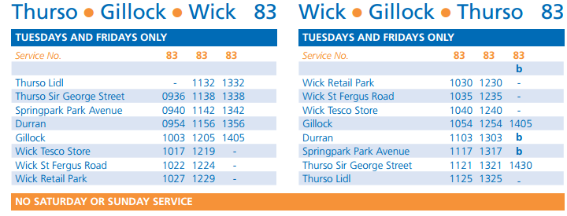
- What is the earliest time I can get a bus to Wick from Gillock?
- How long will that bus take to get to Wick Retail Park?
- What time will my return bus be?
- What time will it reach Gillock?
- I want to get the 12 30 bus from Wick Retail Park to Thurso Lidls. What time will it arrive at Thurso Lidls?
- Write this time in 12 hour clock.
- How long will the journey take?
- What time does the first bus from Thurso Lidls to Wick leave on a Wednesday?

